FOR IMMEDIATE RELEASE
Media Contact:
Bethany Rine, Communications Coordinator
bethany.rine@nwasunshineschool.org // 479.636.3190 x190

SUNSHINE SCHOOL & DEVELOPMENT CENTER CELEBRATES 60 YEARS!
Featuring two celebratory events
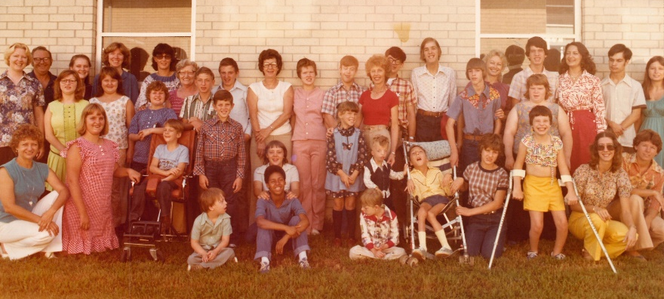
ROGERS, September 12, 2018 – Sunshine School & Development Center has been serving NWA for 60 years. The inaugural class was held in the basement of the First United Methodist Church in Rogers and consisted of two children, one with Down Syndrome and the other with a severe brain injury resulting in developmental delays. In 1958 the public education system didn’t have a place for children with special needs. The families of these two children – the Clardys and the Brileys – needed a place for their own children to learn, so they started Sunshine School. This fall, Sunshine School celebrates the past 60 years of developing and enriching lives.

The 60th Anniversary Picnic with a time capsule dedication will be held with current staff and families on Saturday, September 22 from 11 am to 1 pm at Sunshine School & Development Center.
The 60th Anniversary Celebration featuring A Very Special Art Auction will be held at Record in Downtown Bentonville on Thursday, November 8, from 6:30 to 9:30 pm. This will be an evening of celebrating 60 years of sunshine and miracles and looking ahead to how Sunshine School can continue to serve the NWA community. There will be a silent auction featuring art from Sunshine School clients. Tickets and event sponsorships for the 60th Anniversary Celebration are being sold online at nwaSunshineSchool.org/special-events.
About Sunshine School & Development Center:
Our mission is developing and enriching the lives of individuals and families through therapy, education and support. We envision a world where individuals have the resources they need to reach their full potential as active members in their communities. Visit nwaSunshineSchool.org or call 479.636.3190 for further information.
###

